|  |
| --- |
| SIGHTLINE CAPSTONE PROJECT |
| STATEMENT OF WORK |
| UAV PLUG AND PLAY PRECISION LANDING AID |

# Team members:

**Tai Pham**

**Kimball Davis**

**Adel Alkharraz**

# advisor:

**Professor Roy Kravitz**

# Date: 01 / 11 / 2019

**PROJECT OVERVIEW**

### **BACKGROUND**

### SightLine Applications has developed a precision visual landing algorithm that provides an excellent set of benefits:

* Works in degraded and denied GPS environments – Safety and reliability.
* Reduces operator training and landing phase complexity.
* Provides detection functions for landing zone safety - detect people, animals, or objects from entering the landing zone
* Provides a rich set of telemetry for flight controllers. 30 Hz data with range, XY offsets, relative azimuth, etc.
* Supports landing on moving platforms - ground vehicles, marine.
* Is not impacted by bright sun or low light conditions.
* Can be used with Thermal (IR) cameras as well as visible (EO) cameras
* Effective range of operation (distance to target) only limited by the size of the landing pattern used

### **PROBLEM**

Integration of the SightLine Landing Aid for end users is problematic. Often drone operators want to just “plug in” a component and fly their mission. Installing software components is acceptable, but any requirement for programming is a barrier to entry or a complete show stopper. Various cables, power, and other electrical connectivity issues are also difficult for vehicle integrators. Rugged or at least robust mechanical enclosures, easy mounting, and environmental reliability are equally important. Lastly, choice of optical system (camera) for the greatest range has cause adoption delays in that it has been a decision left to the integrator. Recognizing the needs from the end-users and the current developed benefits, Sightline wants to develop a plug and play precision landing aid for UAVs and expect that this new project will be highly valuable to a wide range of multi-copter integrators.

**PROJECT REQUIREMENTS**

* Develop a set of electrical sub-assemblies that will allow integration of Sightline Precision Landing Aid (1500 OEM + Airborne Camera + accessories) for PX4 running on Pixhawk 4 autopilot
* Design and produce a prototype enclosure for the hardware. The enclosure should be smaller than 3” x 2” x 2”
* Develop documentation and software installers to meet plug and play expectations

**PROJECT DESIGN SPECIFICATIONS**

* Use Pixhawk 4 autopilot
* Use PX4 as an open source flight control software for drones
* Use QGROUNDCONTROL as a ground control station and mission planning
* 1500 OEM and its accessories are powered using 5V output from the Pixhawk 4 kits
* Use RS-232 or 3.3V TTL to communicate between hardware and autopilot
* Use DJI Flame Wheel F450 quadcopter

**LEVEL 0 BLOCK DIAGRAMS**

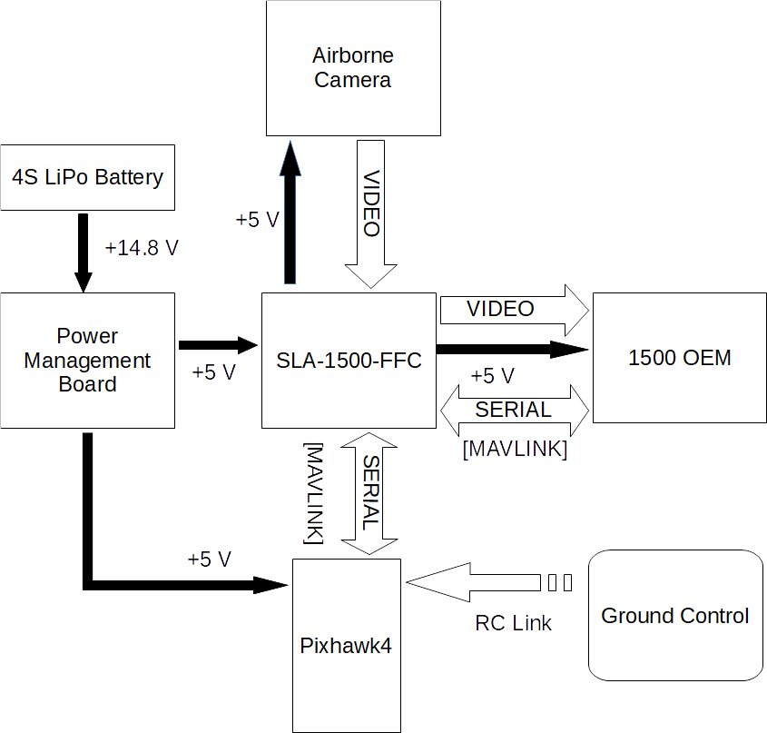

Figure 1: Level 0 diagram of current configuration

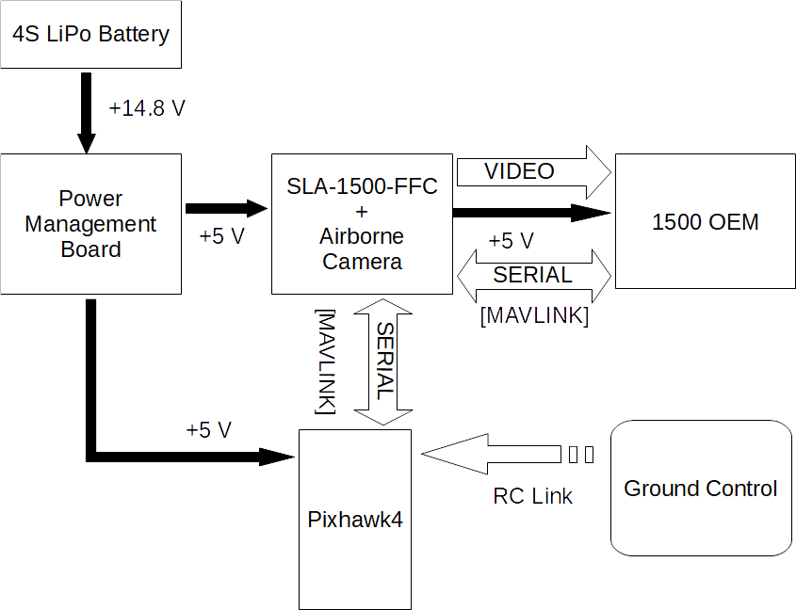

Figure 2: Level 0 diagram of desired configuration

**HARDWARE AND SOFTWARE REQUIREMENTS**

**HARDWARE**

The system will be powered by a Gens Ace 4S LiPo Battery. This battery will deliver 14.8 V to the power management board. The power management board distributes power to the Pixhawk 4, the ESCs, and has a 5 V output for the new board we are integrating which in turn will supply power the 1500 OEM. The power management board also distributes the PWM signals from Pixhawk to the motors. Also, the more details of how to connect Pixhawk 4 with other parts of the design can be found [here](https://docs.px4.io/en/assembly/quick_start_pixhawk4.html).

The battery connectors, 5 V output, ESCs, and Motors are all soldered directly to the PM board. The power and PWM signals are connected to the PM board with included cables. The specifications for the PM07 power management board are given below.

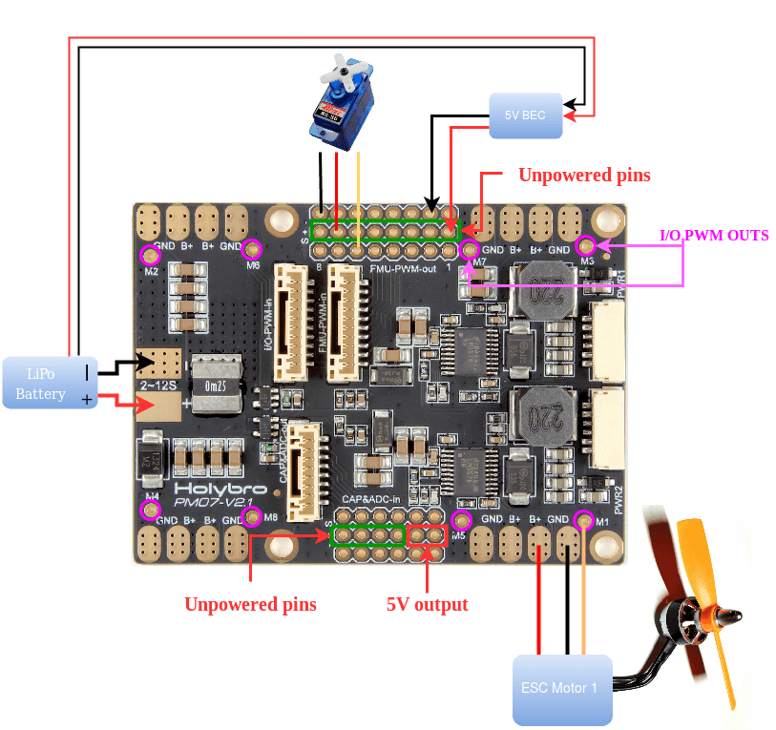

Figure 3: Power Management Board

(Retrieved from <https://docs.px4.io/en/assembly/quick_start_pixhawk4.html> on 13 Jan 2019)

**Specifications**：

* PCB Current: total 120A outputs (MAX)
* UBEC 5v output current :3A
* UBEC input voltage : 7~51v (2~12s LiPo)
* Dimensions:68*50*8 mm
* Mounting Holes:45*45mm Weight: 36g

Note that the 1500 OEM and its accessories which included the Airborne camera and FFC board, which is for testing purpose only, are provided by Sightline.

The new board we are designing will send video and distribute power to the 1500 OEM. It will also facilitate serial communication between the Pixhawk 4 and the 1500 OEM. The default port for MAVLINK communication is TELEM1 which uses a 6-pin JST GH connector.

The 1500 OEM will connect to the new board with a 50-pin Hirose DF12B connector which is provided by Sightline.

The Airborne camera we are using for this project is based on the AR0134CS image sensor evaluation board. The AR0134CS from ON Semiconductor is a 1/3-inch 1.2 MP CMOS digital image sensor with an active-pixel array of 1280 (H) × 960 (V). The AR0134CS has the following key performance parameters.

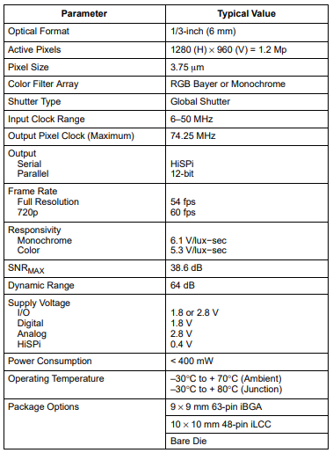

Figure 5: Key Performance Parameters of AR0134CS

Most of the hardware design for this project will be redesigning the AR0134CS evaluation board to have the 50-pin Hirose connector for direct connection to the 1500 OEM.

Information on the DJI F450 quadcopter we are using for testing can be found [here.](https://github.com/phamtaiece/Capstone-Sightline/tree/master/Quad_Copter)

**SOFTWARE**

In this project, we decided to use PX4 autopilot and Q-groundcontrol as the software platform. In addition, for Pixhawk 4, the firmware is pre-built and installed automatically when it is connected to the Q-groundcontrol via USB cable. The newest version of firmware for Pixhawk 4 is fmu-v5.

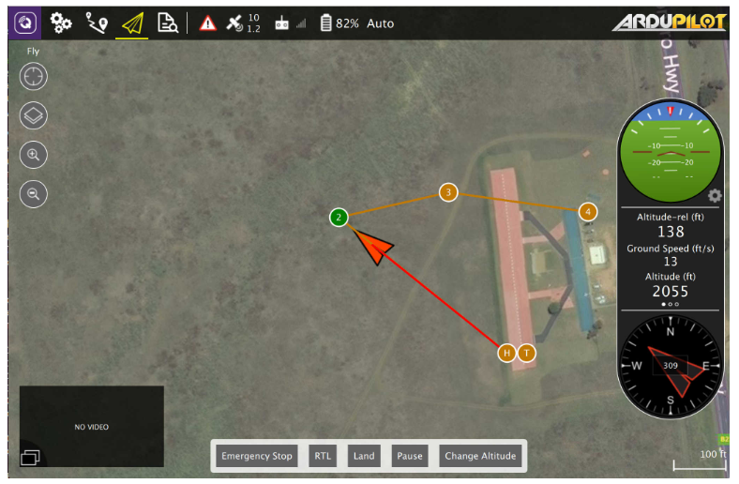

**Figure 6**. Q-groundcontrol interface

(Retrieved from <https://docs.qgroundcontrol.com/en/> on 13 Jan 2019)

The airframe needed to be selected in Q-groundcontrol interface is DJI Flame Wheel F450. The Pixhawk 4 orientation (the arrow) must be pointed towards the front of the vehicle. The orientation of Piwhawk 4 is shown below. For more information about how to set up PX4 and Q-groundtrol to work with Pixhawk 4, we can find [here](https://docs.px4.io/en/getting_started/). However, it’s very nice that the PX4 website also has a very interesting video which introduces step-by-step how to setup PX4 autopilot using Q-groundcontrol connected to Pixhawk 4. The video can be retrieved [here](https://docs.px4.io/en/config/).

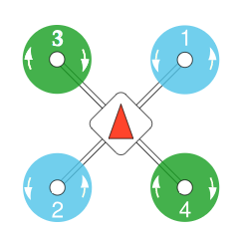

Figure 7. Pixhawk 4’s orientation on Quadrotorx, namely DJI Flame Wheel F450.

(Retrieved from <https://docs.px4.io/en/airframes/airframe_reference.html> on 13 Jan 2019)

**FIRST ORDER COST ESTIMATE**

|  |  |  |  |  |
| --- | --- | --- | --- | --- |
| UAV Plug and Play Precision Landing Aid | | | | |
| Qty | **Hardware description** | **Mfg** | **Unit cost** | **Total Cost** |
| 1 | DJI FLAMEWHEEL F450 ARF KIT | DJI | $229.00 | $229.00 |
| 1 | DJI FLAMEWHEEL LANDING GEAR (4 pcs) | DJI | $17.50 | $17.50 |
| 1 | FrSky Taranis X9D Plus 16-Channel 2.4ghz ACCST Radio Transmitter | FrSky | $229.00 | $229.00 |
| 1 | FrSky X4RSB 3/16CH Telemetry Receiver Full Range | FrSky | $31.99 | $31.99 |
| 4 | Gens ace 14.8V 5000mAh 45C 4S LiPo Battery Pack | Gens Ace | $64.99 | $259.96 |
| 1 | PIXHAWK 4 ADVANCED DEVELOPMENT KIT | Holybro | $210.95 | $210.95 |
|  |  |  | **Total:** | $978.40 |

**TIMELINE**

Winter term 2019 – Tentative Schedule

[Click here for Project Timelines (Gantt Chart)](https://github.com/phamtaiece/Capstone-Sightline/blob/master/Project%20Timelines/Sightline_ProjectTimelines.pdf)

**Week 1: 01/07 – 01/13**

* Finish a first draft version of Statement of Work
* Do Q-groundcontrol learning and researching
* Create a tentative schedule for our project
* Ask question?

**Week 2: 01/14 – 01/20**

* Complete Statement of Work
* Do Q-groundcontrol learning
* Do Pixhawk 4 learning
* Answer “How to fly indoor safely”
* Review Jeremy question in Docs
* Ask question?

**Week 3: 01/21 – 01/27**

* Start understanding the sample code
* Expect to receive the quadcopter from Sightline.
* Do Quadcopter learning
* Do Pixhawk 4 learning
* Ask Question?

**Week 4: 01/28 – 02/03**

* Learn from the sample Code (cont)
* Expect Pixhawk 4 arrive at Sightline
* Do Pixhawk 4 learning
* Do Quadcopter learning
* Start drawing schematic for new board
* Ask question?

**Week 5: 02/04 – 02/10**

* Draw schematic for new board (cont)
* Start working with quadcopter + Pixhawk 4 + Q-groundcontrol
* Code writing
* Ask question?

**Week 6: 02/11 – 02/17**

* Send schematic for manufacture (expect 2 weeks)
* Start working with quadcopter + Pixhawk 4 + Q-groundcontrol (cont)
* Code writing (cont)
* Ask question?

**Week 7: 02/18 – 02/24**

* Start working with quadcopter + Pixhawk 4 + Q-groundcontrol (cont)
* Code writing (cont)
* Working with simulation model
* Ask question?

**Week 8: 02/25 – 03/03**

* New board arrives at Sightline
* Schematic test and debug
* Code writing (test)
* Working with simulation model
* Ask question?

**Week 9: 03/03 – 03/10**

* Schematic test and debug
* Enclosure 3D model create
* Working with simulation model
* Ask question?

**Week 10: 03/11- 03/17**

* Schematic test and debug (cont)
* Enclosure 3D model create (cont)
* First demo

**Reference**

**Dronecode**, PX4 Autopilot, <https://docs.px4.io/en/>, retrieved on 13 Jan 2019.

**Dronecode**, Q-groundcontrol, <https://docs.qgroundcontrol.com/en/>, retrieved on 13 Jan 2019

**Dronecode**, Pixhawk 4 User Guide, <https://docs.px4.io/en/flight_controller/pixhawk4.html>, retrieved on 13 Jan 2019.

**Sightline Application**, SLA_1500_FFC schematic

**ON Semiconductor**, Key Performance Parameters of AR0134CS.